# Amazon Simple Storage Service (Amazon S3)

## AWS Object Storage Service

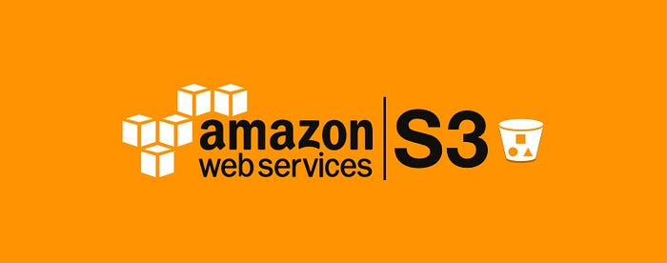

This is a quick read article about [Amazon Simple Storage Service](https://docs.aws.amazon.com/AmazonS3/latest/userguide/Welcome.html) (Amazon S3) and part of the major ‘[**Hosting my Static Website in an AWS S3 Bucket**](https://medium.com/@rogernem/hosting-my-static-website-in-an-aws-s3-bucket-d5e1d94417f4#4a10)’ one.

At the time of writing it, [Amazon Web Services (AWS)](https://medium.com/@rogernem/amazon-simple-storage-service-eb0808cf30d5#6a2f) offers over 200 fully featured services and [Amazon Simple Storage Service](https://docs.aws.amazon.com/AmazonS3/latest/userguide/Welcome.html) (Amazon S3) is an **object storage service** that offers industry-leading scalability, data availability, security, and performance.

An Amazon S3 bucket is a public cloud storage resource available in [Amazon Simple Storage Service](https://docs.aws.amazon.com/AmazonS3/latest/userguide/Welcome.html) (Amazon S3) platform. Data is stored inside S3 buckets in distinct units called objects instead of files.

Amazon S3 buckets are similar to file folders and can be used to store, retrieve, back up and access objects. Each object has three main components — the object’s content or data, a unique identifier for the object and the descriptive metadata, including the object’s name, URL and size.

[Amazon Simple Storage Service](https://docs.aws.amazon.com/AmazonS3/latest/userguide/Welcome.html) (Amazon S3) offers a plethora of benefits, making it a widely adopted and versatile storage solution.

Below are some key benefits of using AWS S3 buckets:

1. **Scalability and Flexibility:**

* S3 provides virtually unlimited storage capacity, allowing users to scale their storage needs seamlessly as their data grows.
* It accommodates a wide range of use cases, from small-scale applications to large-scale enterprises.

**2. Durability and Reliability:**

* S3 is designed for 99.999999999% (11 9’s) durability of objects over a given year. It replicates data across multiple geographically dispersed data centers.
* Redundancy and automatic error-checking mechanisms ensure high availability and reliability.

**3. Security:**

* S3 integrates with AWS Identity and Access Management (IAM) to control access to buckets and objects.
* It supports encryption at rest and in transit, ensuring the confidentiality and integrity of stored data.

**4. Cost-Effective:**

* Users pay only for the storage they use, and S3 offers different storage classes with varying costs based on retrieval frequency and durability requirements.
* The pay-as-you-go pricing model eliminates upfront costs and allows for cost optimization.

**5. Ease of Use:**

* S3 is designed for simplicity, with an easy-to-use web interface and compatibility with a variety of SDKs and tools.
* Versioning, lifecycle policies, and other features make data management straightforward.

6. **Data Management and Analytics:**

* S3 supports versioning, allowing users to archive, retrieve, and restore previous versions of objects.
* Integration with AWS analytics services like Amazon Athena and Amazon Redshift facilitates efficient data analysis.

7. **Content Delivery:**

* S3 integrates seamlessly with Amazon CloudFront for content delivery, enabling low-latency distribution of content to end-users globally.
* This improves the performance and user experience of applications with high data transfer requirements.

8. **Compliance and Auditing:**

* S3 assists in meeting regulatory requirements and compliance standards.
* Detailed logging and monitoring features enable auditing of bucket access and changes.

## Amazon S3 Use Cases

Amazon S3 has many [use cases](https://docs.aws.amazon.com/AmazonS3/latest/gsg/S3-gsg-CommonUseScenarios.html), including:  
- Static Website Hosting  
- Security and Compliance  
- Storage for Internet  
- Backup and Disaster Recovery  
- Data Archiving  
- Analytics

Now that you know more about Amazon S3, click below to continue reading the major article.

**If you enjoyed this article and found it helpful, please don’t forget to leave a heart** ❤**, comment** 💬**, clap** 👏🏻**, and share** ➦ **it to show your support.**

**Also, don’t forget to** [**follow me**](https://medium.com/@rogernem) **for more articles. Thank you!**